|  |  |
| --- | --- |
| To: | **General Purposes Licensing Casework Sub Committee** |
| Date: | **22 October 2024** |
| Report of: | **Head of Planning & Regulatory Services** |
| Title of Report: | Peripatetic Street Trading application (Lucy Hedges: Full of Beans) |

|  |  |  |
| --- | --- | --- |
| Summary and recommendations | | |
| Purpose of report: | | To inform the determination of a street trading application |
| Corporate Priority: | | Enable an inclusive economy  Support thriving communities |
| Policy Framework: | | Street trading Policy 2024  Council Strategy 2020-2024 |
| Recommendation(s): That the General Purposes Licensing Casework Sub-Committee resolves to: | | |
| 1. | Determine the applications, taking into account the details in this report and any representations made at this Sub-Committee meeting. | |

# Introduction and background

1. In 1986 the Council resolved that Schedule 4 to the Local Government (Miscellaneous Provisions) Act 1982 should apply to its area. Under Schedule 4 the Council can manage street trading by designating streets as “consent streets”, “licence streets” or “prohibited streets”. All streets within Oxford are currently designated “consent streets” and any trading requires the grant of a street trading consent. Street trading consent may be granted as the Council “thinks fit”. When exercising the power to grant and enforce consents the Sub Committee should only take into account relevant considerations; must give each applicant or consent holder a fair hearing and should give reasons for their decisions.
2. Street trading consent is granted subject to the Council’s standard conditions. The Sub Committee may amend or attach any additional conditions to a Consent that it considers “reasonably necessary”.
3. The application (appendix 1) is for a peripatetic street trading consent.
4. This type of consent limits the trading to 20 minute periods on a route. The proposed route can be found in appendix 2.
5. The proposed trading unit is a purpose built converted tricycle with a coffee machine on (see picture in appendices).
6. The applicant asks to trade for a 20 minute period between 06.30 and 14:00 on Saturdays at the proposed route set out in appendix 2, and provides the reasons for requesting these hours in the application.

**Determination of Applications for Consent**

1. Prior to a Consent being granted or refused, the application is subject to a 14 day consultation period with stakeholders being given the opportunity to share observations and concerns. Our stakeholders include Oxfordshire County Council Highways Authority, Thames Valley Police, Oxford City Council Planning Service, Oxford City Council Environmental Health Services (Commercial Pollution and Food Safety) and Ward Councillors. All comments received are taken into consideration when determining the grant of a Consent.
2. The Street Trading Policy 2023 requires new Street Trading applications to be referred to the Council’s General Purposes Licensing Casework Sub-Committee who will use the criteria listed in the Policy in their determination of the application. A range of Criteria are listed, with each case being assessed on its merits and individual circumstances, where appropriate, may be taken into consideration. When there are representations relating to public safety, the Responsible Head of Service acting under delegated powers may refuse an application.

**Reason for referral to Licensing Sub Committee**

1. The application is referred to the Licensing Sub Committee as per the point above. The application and relevant supporting documents can be found in the appendix to this report.
2. Comments made in response to the consultation process have been included in appendix 4.
3. Any consent granted will be subject to the satisfactory receipt of all of the required documentation listed in section 6.1 of the Street Trading Policy.
4. Any consent granted will be issued to expire on 31 March 2025 in line with the Council policy of having a single renewal date. The successful applicant would need to submit a renewal application to the Council prior to 1 February 2025 should they wish to continue trading after 31 March 2025.
5. The options before the committee are:
   1. To grant the peripatitc street trading consent as applied for; or
   2. To grant the peripatetic street trading consent with additional conditions; or
   3. To refuse the application for a peripatetic street trading consent.
6. In doing so the committee can add or amend any conditions it thinks reasonable to achieve the aims detailed in the policy considerations below.

**Policy Considerations**

1. The Policy requires that when determining an application for the grant or renewal of a Consent, the Council will consider the following factors, as per section 6.8 of the Policy:

**(a) Public safety**

Whether the street trading activity represents, or is likely to represent, a substantial risk to the public. Factors taken into account will include: obstruction, fire hazard, unhygienic conditions or danger that may occur when a trader is accessing the site.

**(b) Public order**

Whether the street trading activity represents, or is likely to represent, a substantial risk to public order.

**(c) Avoidance of public nuisance**

Whether the street trading activity represents, or is likely to represent, a substantial risk of nuisance to the public, particularly in residential areas.

**(d) Appearance of the stall or vehicle**

The stall or vehicle must be maintained in good condition, be of smart appearance and meet the criteria, including size, laid down in the standard Consent Conditions. Photographs or sketches, including dimensions, must be provided with all new applications and requests for approval of changes to or replacement of a stall or vehicle. The general appearance of the vehicle or stall will also be considered in order to determine that the unit will not detract from the appearance of the surrounding area.

(**e) Needs of the area**

The demand for the articles for sale and the geographical location of the proposed site.

**(f) Environmental sustainability**

Measures to minimise the impact of the proposed operation on the local environment including street surfaces and materials, power supply, carbon footprint, supply chain, packaging, waste minimisation, recycling and waste disposal.

**(g) Food safety and food offer**

Applicants to trade in hot or cold food must be able to demonstrate a good understanding of food safety and be registered as a food business with the relevant local authority. As a minimum, food handlers must hold a current Level 2 Award in Food Safety in Catering accredited by The Chartered Institute of Environmental Health or The Royal Institute for Public Health. Consideration will be given to applicant’s ability to meet SUGAR SMART Oxford criteria (see Annex 3 for guidance).

**(h) Highway safety** The location and operating times will be such that the highway can be maintained in accordance with the Oxfordshire County Council’s requirements and that there are no dangers to those who have a right to use the highway and no obstruction for emergency access.

1. The application has been assessed against the required criteria and is considered to be valid.

# Financial implications

1. The Council collects fees for Street Trading Consents. Predicted income from Consent fees are included in the Council’s budget.

# Legal issues

1. The Sub Committee may grant a Street Trading Consent if it ‘thinks fit’. Consent may be revoked at any time. A street trader cannot be said to enjoy security of tenure and there is no requirement for the Council to give compensation for the loss of any Consent (other than any refund of Consent fees paid in advance). However, any decision to refuse an application or terminate Street Trading Consents may be subject to a judicial review and if held to be unreasonable then compensation may result.
2. Any determination of an application for Consent must be proportionate taking into account all relevant circumstances and the Consent holder’s right to a fair hearing. An application should not be refused arbitrarily and without clear reason.

**Human Rights Act Considerations**

1. Article 1 of the first Protocol of the European Convention on Human Rights provides that every person is entitled to the peaceful enjoyment of his possessions. No one shall be deprived of his possessions except in the public interest and subject to the conditions provided for by law. However a street trading consent is not generally considered to be a possession in law and the protection in Article 1 is therefore not directly engaged.

**Equality Act Considerations**

1. The Council has a Public Sector Equality Duty under the Equality Act 2010 to have due regard to the need to:

* Eliminate discrimination, harassment and victimisation and any other conduct that is prohibited by or under the Act;
* Advance equality of opportunity between people who share a relevant protected characteristic and those who don’t share it;
* Foster good relations between people who share a relevant protected characteristic and those who do not (which involves having due regard, in particular, to the need to tackle prejudice and promote understanding.

**Environmental Considerations**

1. There are no environmental considerations arising directly from this report.

|  |  |
| --- | --- |
| **Report author** | Matthew Stead |
| Job title | Senior Licensing Officer |
| Service area or department | Regulatory Services & Community Safety |
| Telephone | 01865 335771 |
| e-mail | mstead@oxford.gov.uk |

|  |  |
| --- | --- |
| **Appendices** | |
| Appendix 1 | Application form |
| Appendix 2 | Proposed peripatetic trading route |
| Appendix 3 | Picture of proposed trading unit |
| Appendix 4 | Comments received from consultation |
| Appendix 5 | Peripatetic Street Trading Consent Standrard Conditions |

**Appendix 1: Application Pack**

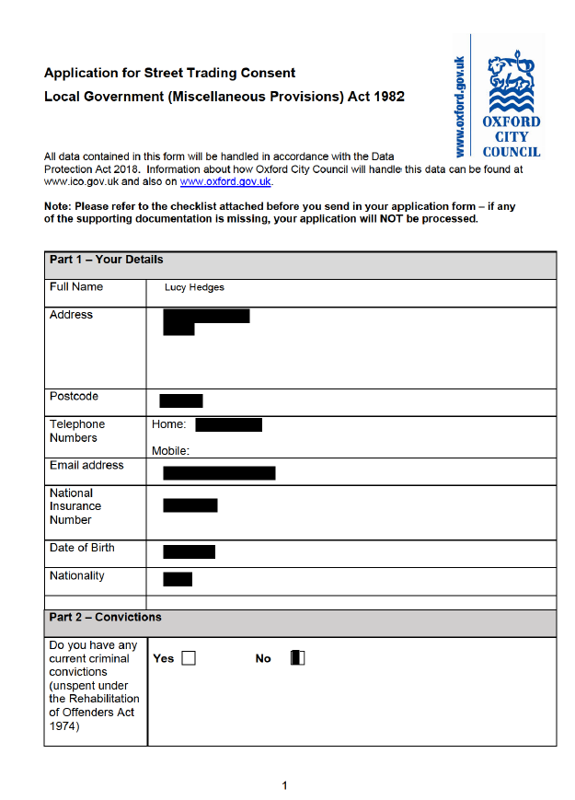

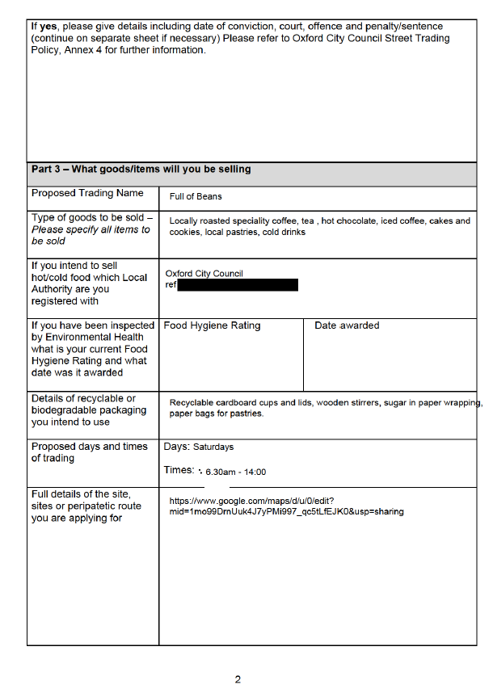

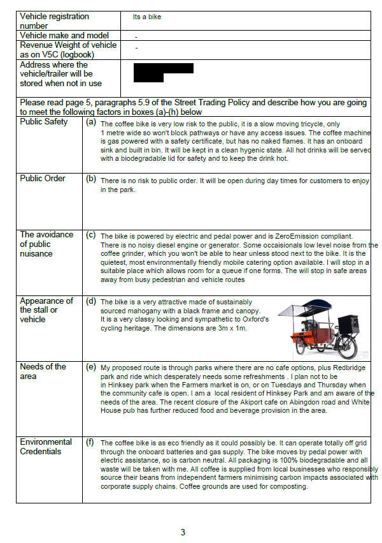

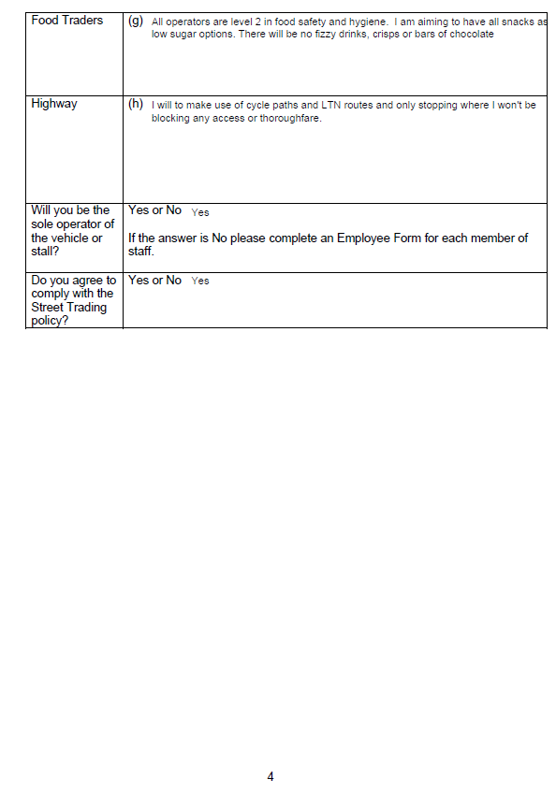



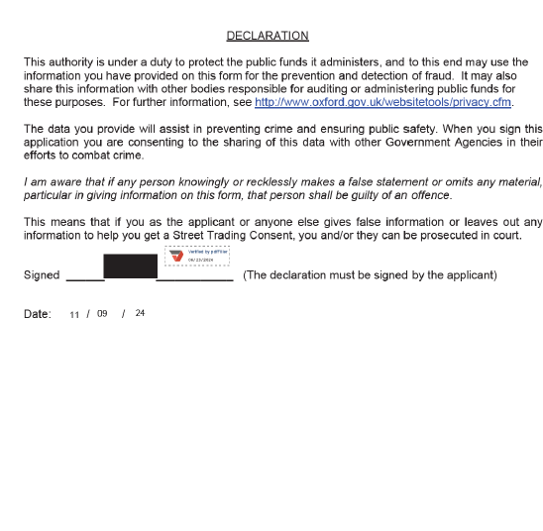

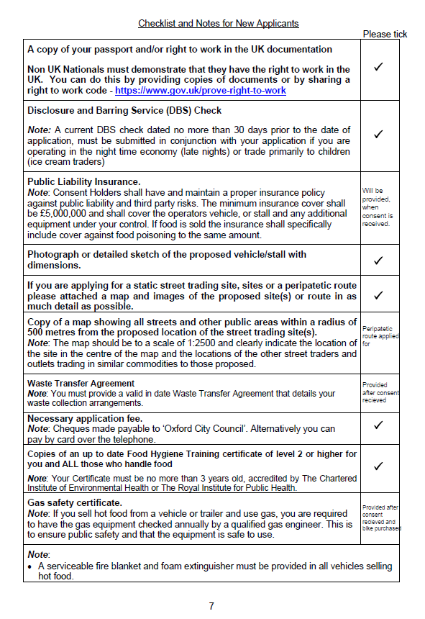

**Appendix 2**

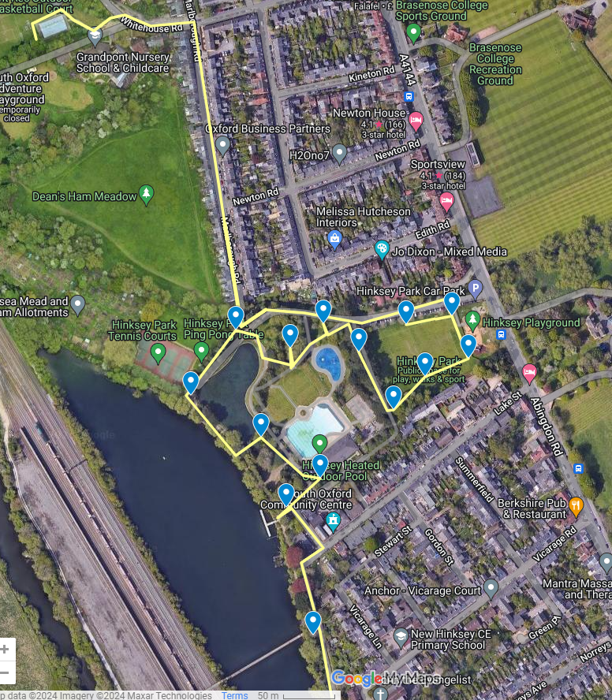

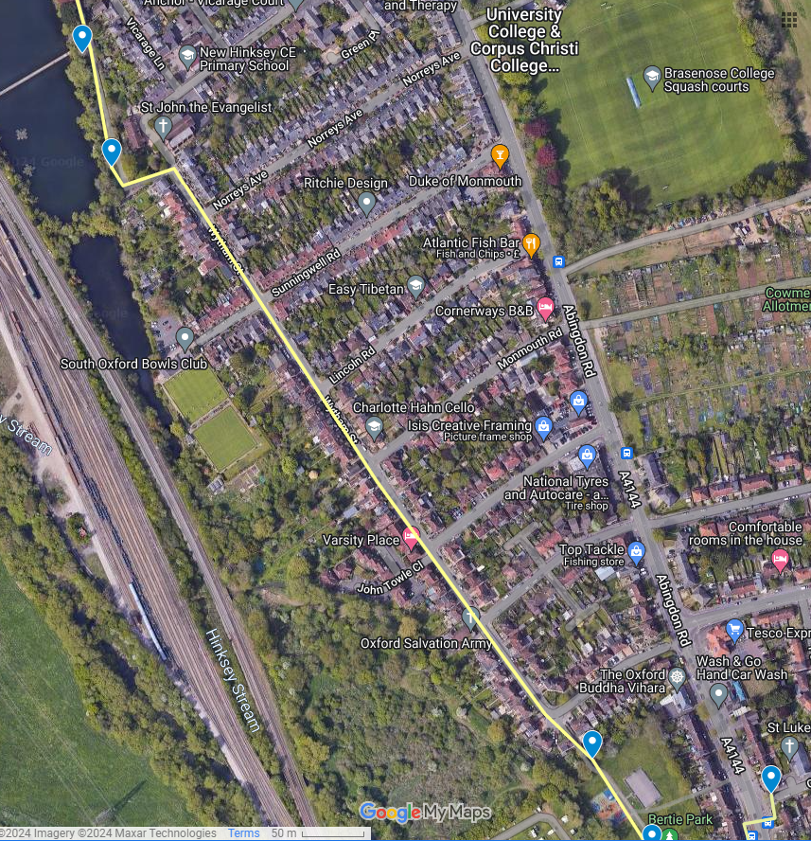

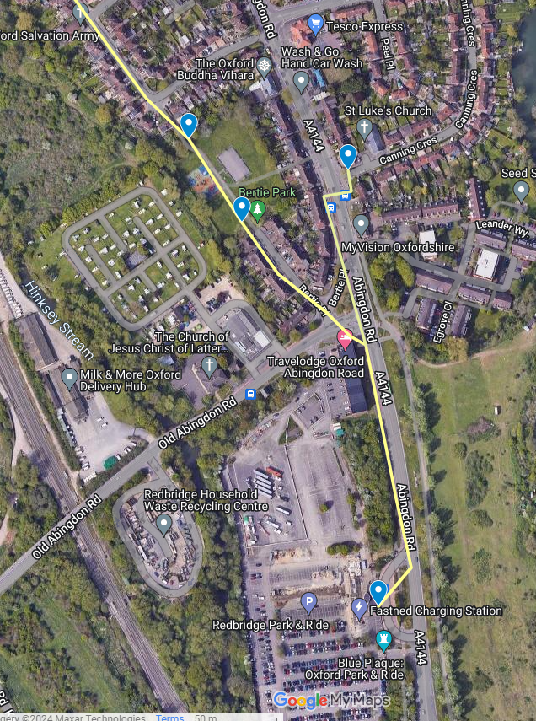

**Appendix 3**

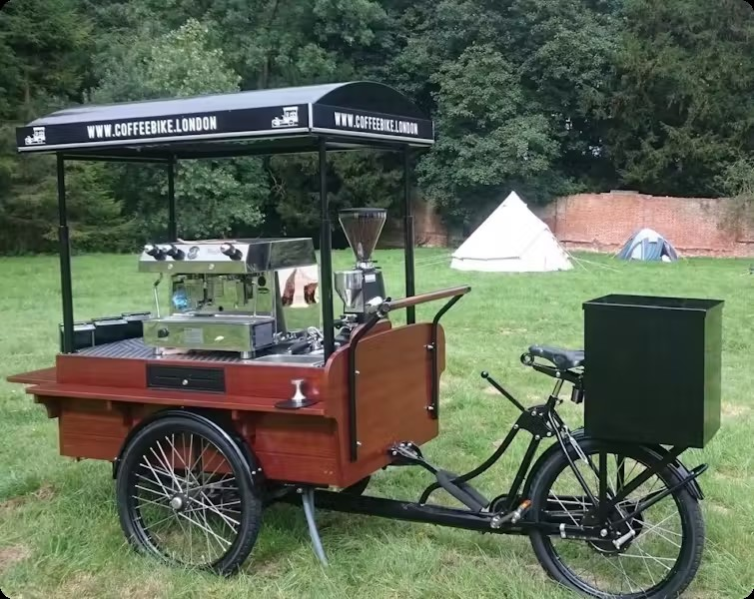

**Appendix 4**

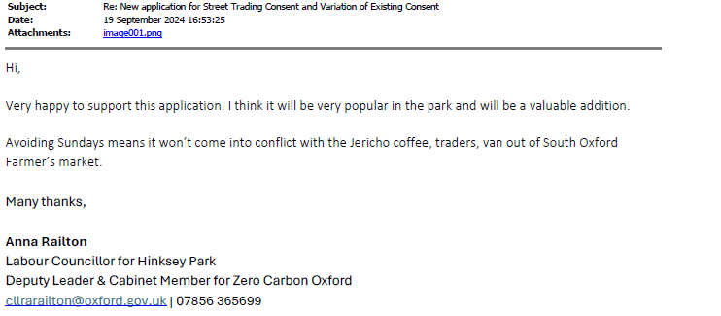

# Appendix 5

**General Conditions for Street Trading Consents**

1. Street trading must only take place between the dates specified on the Certificate of Street Trading Consent.
2. Street trading must only take place during the operational hours specified on the Certificate of Street Trading Consent.
3. The Street Trading Consent relates only to the area/site vehicle or stall specified on the Certificate of Street Trading Consent.
4. The Street Trading Consent relates only to the vehicle or stall specified on the Certificate of Street Trading Consent.
5. Any significant changes to or replacement of a stall or vehicle must be approved by the Responsible Head of Service.
6. The vehicle or stall must be removed from the site at the end of each day’s trading.
7. The Consent Holder’s vehicle/stall must be kept in a clean, safe and well maintained condition and be of a presentable appearance. The Street Trading Consent bearing the name of the consent holder shall be displayed conspicuously on the stall/vehicle so that members of the public can clearly see it during hours of business.
8. The Consent Holder’s vehicle must be maintained in a roadworthy condition, taxed, insured and with a current MOT Certificate. Vehicle movements must be carried out legally and must not present a risk to people and structures. The Consent Holder shall not drive or park a vehicle on any part of a footway.
9. The Consent Holder must ensure that the stall/vehicle is positioned only in the allocated space (which may be marked on the ground) in the Consent Street for which the Street Trading Consent is issued.
10. If a Consent Holder or operator/assistant is requested to move the vehicle/stall by an authorised Council Officer or Police Officer they must immediately comply with that request.
11. The Consent Holder must comply with all statutes, statutory instruments and byelaws currently in force. Consent Holders must pay particular attention to the requirements of the Health & Safety at Work etc. Act, 1974 and the Food Safety and Hygiene (England) Regulations 2013 (where relevant). Advice on these requirements is available from the Business Regulation Team.
12. The Consent Holder must conduct their business in a professional manner and in a way that minimises risks to employees and others.
13. The Consent Holder must take reasonable precautions to prevent the risk of fire at the stall or vehicle. All hot food vans/trailers are required to comply with current legislation on fire safety. A serviceable fire blanket and a suitable fire extinguisher shall be provided in all vehicles selling hot food.
14. Reasonable steps must be taken to ensure gas safety where gas appliances are used on a stall or vehicle. Gas appliances must be maintained and serviced as per manufacturer’s instructions. Gas appliances and systems must be checked for safety by a competent Gas Safe engineer at least annually. Any faults or concerns in relation to gas safety must be appropriately investigated and made safe by a competent Gas Safe engineer as soon as possible.
15. The Consent Holder must not cause any nuisance or annoyance to any other user of the highway or the occupier of any land or building. In particular, Consent Holders must prevent excessive noise.
16. The Environmental Protection Act 1990 (as amended) places a duty of care on businesses to dispose of their trade waste in an appropriate manner. Trade waste must be stored appropriately and be disposed of by a licensed waste carrier. No water or waste material shall be discharged on to the highway or any adjacent property.
17. The Consent holder shall take reasonable steps to ensure that litter arising from their own trade is minimised as far as possible, including by making a bin available for customers to use where a public litter bin is not available within 20 metres from their vehicle.
18. A Street Trading Consent must not be transferred or sold to another person except that the Consent may be transferred to a member of the Consent Holder’s immediate family in the event of the Consent Holder’s death or incapacity on payment of a fee. The subletting of a consent site is prohibited.
19. The Consent Holder must be the principal operator and have day to day control of the stall/vehicle. The Consent Holder may employ any other person to assist in operating the stall/vehicle and shall notify the Council of the name and address of that person. An administration fee will be payable.
20. Anyone who operates a stall/vehicle other than the Consent Holder must be authorised by the Council.
21. Consent holders must make adequate provisions to ensure access for wheelchair users or customers with disabilities.
22. A copy of the Consent must be displayed by the operator when trading and must be produced on demand to a Council Officer or Police Officer.
23. Consent Holders must have and maintain a proper insurance policy against public liability and third party risks. The minimum insurance cover shall be £5,000,000 and shall cover the operator’s vehicle, or stall and any additional equipment under their control. If food is sold the insurance must specifically include cover against food poisoning to the same amount. Proof of cover must be produced to an officer of Oxford City Council on application and as required.
24. Annual Street Trading Consent fee installments are required quarterly, in advance. The first installment must be paid in advance of the issue of Consent. The remaining fee can be paid in instalments on the following dates 1st July. 1st October and 2nd January. Alternatively, annual fees may be paid in full in advance.
25. General Conditions, which apply to all Street Trading in Oxford, may be varied, having regard to a particular location. They are termed Special Conditions and are listed on the Consent Certificate. These Special Conditions must also be complied with.
26. Consent holders must make full use of their Consent.
27. Consent holders must not sell any of the following items: Tobacco, tobacco products or e-cigarettes; items made of animal fur; items that cause or contribute to crime and disorder; energy drinks to children below 16 years old; plastic and helium balloons and sky lanterns
28. Consent holders must not use, sell or distribute single-use plastic in street trading in Oxford

**Conditions Specific to Food Traders**

1. Food businesses must achieve and maintain a minimum Food Hygiene Rating of ‘3 – Generally Satisfactory’. The Hygiene Rating must be displayed prominently on the stall or vehicle.
2. Food handlers must hold a Level 2 Award in Food Safety in Catering accredited by The Chartered Institute of Environmental Health or The Royal Institute for Public Health with a certificate dated within the last 3 years...
3. Food businesses must be registered as a food business with the Local Authority where the van/stall is kept overnight. Food businesses registered outside of the Oxford City Council area must be able to demonstrate food business registration, e.g. by written confirmation from the relevant local authority or by providing a copy of the latest inspection letter or report. Any changes in registration details must be notified to the relevant Local Authority.
4. All hot food vans/trailers are required to carry a basic first aid kit and have the means to contact the emergency services if necessary.

**Conditions Specific to Peripatetic Traders**

1. The Consent holder is required to comply with the Code of Practice on Noise from Ice-Cream Van Chimes Etc. in England 2013 or any modification or re- enactment thereof.
2. The vehicle must not trade within 100 metres of the boundary of any school or college between the hours of 07:30 and 18:00 (without formal invitation from the establishment).
3. The vehicle must not wait in one location for more than twenty minutes, moving at least 50 metres to the next trading location. The vehicle must not return to that location within four hours.

**Conditions Specific to Weekly Street Traders**

1. Weekly Street Trading Consents fees must be paid two weeks in advance before trading commences. This is to allow sufficient time to process the application and receive the consent. Traders must be in possession of their Consents before they can trade.
2. The items to be sold must be agreed before a Weekly Consent will be issued.
3. The sale of food and/or drink is not permitted by Weekly Street Traders.
4. For Weekly Street Traders on Cornmarket Street, the Consent Holder’s stall must not exceed 2.3 metres in height nor occupy an area greater than 2.3 metres x 1.4 metres.

**Failure to comply with these conditions**

If a Consent Holder fails to comply with any of the conditions attached to a Street Trading Consent, the Consent may be suspended for an indefinite period or revoked. The Consent Holder may also be prosecuted.